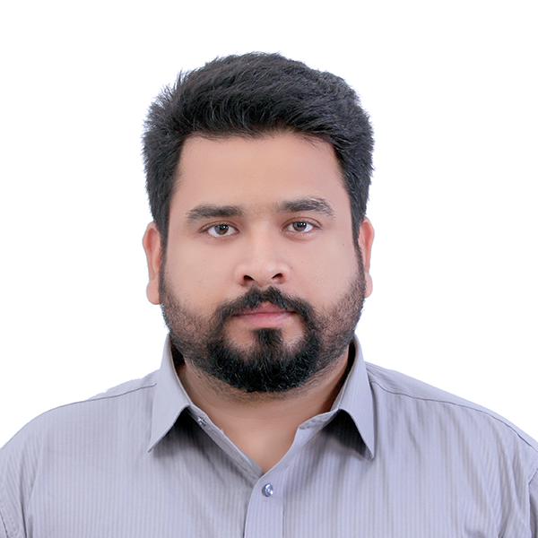
Zulqarnain Haider

Mobile: +971563854943
Mobile: +923007214032
E-mail: nainshah08@gmail.com
United Arab Emirates
Visa Status: Employment Visa
_____________________________________________________________________________

PROFESSIONAL PROFILE

Experience and versatile professional accustomed to work on own initiative in a verity of disciplines. Excellent communication skill with positive and careful approach even under pressure. Looking for a dynamic organization that can provide advancement in career.

Web designer and front-end web developer with more than 11 years of experience with strong technical skills. I have an excellent knowledge of CMS / eCommerce - WordPress, Shopify, Html, CSS, Cross browser and Responsive Layout. Primary focus on web site design and development, specializing in custom WordPress themes. Addition to the above I have good knowledge of IT Support.

PROFESSIONAL Experience

COmpany: Gr8 Services – Top advertising agencies in Dubai, UAE.
Designation: Web developer
(July-2017 – Continue)

- Front-End Web Development – WordPress, Shopify, HTML / XHTML, CSS, JavaScript, SEO.
- Web Design – Visual Layout, Graphical User Interface, Navigational Design, Banner Ads / Email Ads.
- Design and develop web sites from concept to completion, including post production site maintenance.
- Provide internet related services domain name registration, web hosting, search engine optimization / submission.
- Administered project collaboration; solely responsible for digital workflow, backups, and project management.
- Provide technical support to clients.
- Design new features for existing websites.
- Facebook Pixel events implementation on sites.
- HubSpot custom templates creation & design for blog and emails.
- Handle all projects from start to finish, including administrative aspects.
- Add custom HTML (Theme Integration) into WordPress.
- Perform activities to optimize websites for search engine optimization (SEO).
- Perform activities to optimize websites for Google Page Speed on good rank.
- Install different theme and plugins on Wordpress and Shopify for the Sites modifications.
- Testing of web in multiple web browsers and smart phone’s like Tablet, Android and Iphone.
- Thorough understanding of best practices and industry standards.
- Monitor uptime, hosting, and databases to ensure site is performing at maximum capacity.

COmpany: North Tours – Bespoke Destination Management Company Dubai.
Designation: Web developer of WordPress, Joomla, html, and basic php
(June-2015 – Jan-2017)

- Front-End Web Development – WordPress, HTML / XHTML, CSS, JavaScript, SEO.
- Web Design – Visual Layout, Graphical User Interface, Banner Ads / Email Ads.
- Design and develop web sites from concept to completion, including post production site maintenance.
- Provide internet related services domain name registration, web hosting, search engine optimization / submission.
- Handle all projects from start to finish, including administrative aspects.
- Add custom HTML (Theme Integration) into WordPress.
- Work on Sites modification and install different theme and plugins.
- Perform activities to optimize websites for search engine optimization (SEO).
- Social media promotion services Facebook, Twitter and Google plus.
- Email Marketing with sending bulk emails to Company’s Clients database.
- Install different theme and plugins on Wordpress.
- Testing of web in multiple web browsers and smart phone’s like Tablet, Android and Iphone.
- Design and Updating Websites.

COMPANY: Adeveloper web Agency, Pakistan.
Designation: Web developer of WordPress, Joomla, html, and basic php
(June-2014 – April-2015)

- Work on different CMS Wordpress and Magento as a developer.
- Communicate directly with clients to establish project parameters, write proposals for design work, analyze competitor web sites, determine web site content, produce site maps for client approval, and communicate progress with client throughout length of project.
- Add custom HTML (Theme Integration) into Magento and WordPress.
- Work on Woo Commerce modification and install different theme and plugins.
- Install different theme and plugins on Wordpress and Magento.
- Testing of web in multiple web browsers and smart phone’s like Tablet, Android and Iphone.

COMPANY: Wize Dev Technology, Pakistan.
Designation: Web development in Wordpress, Joomla, and html.
(Aug-2011 – May-2014)

- Work as web developer.
- Translating User requirements into technical requirements.
- Testing the requirements with selected template.
- Assist users with process issues and design modifications.
- Well-versed in Google Analytics.
- Perform activities to optimize websites for search engine optimization (SEO).
- Social media promotion services Facebook, Twitter and Google plus.
- Email handling.
- Skilled at helping clients troubleshoot.
- Prepared and presented technical proposals to clients.
- Testing of web in multiple web browsers and smart phone’s like Tablet, Android and Iphone.
- PSD to Wordpress, Joomla, Html conversion.
- Assist in website traffic and performance monitoring.
- Updated posts as appropriate and edited pages as instructed.
- Gathered jpegs and took pictures to post on sites.
- Handled link exchanges and content swaps.
- Any additional task given by management.

Technical Skills

- WordPress
- Shopify
- Magento
- HubSpot
- HTML
- CSS
- Basics Php
- Computer Hardware & software

Operating Software: Windows, Mac.

Office Productivity: Microsoft Office Suite, Dream Weaver, Adobe photo-shop, FTP.

EDUCATION
Bachelor of Computer Science
Virtual University of Pakistan (2014)

(DAE in Electronics) Diploma of Associate Engineer in Electronics
Punjab board of technical education Lahore (2008)

Secondary School certification
(BISE Faisalabad) Board of intermediate and secondary education Faisalabad (2004)

CERTIFICATION
Diploma of electronics equipment repair

(TEVTA) Technical Education & Vocational Training Authority

Short course from Pasban Computer College Faisalabad Pakistan in

- MS Office
- MS Word
- MS Excel
- Power Point
- Internet and E-Mail
- Windows installation

Personal Details

Nationality | : | Pakistan
Date of Birth | : | 08th October 1988
Marital Status | : | Single
Languages | : | English, Urdu, Punjabi
Extra-Curricular activities | : | Net Surfing, Gym, Books reading.
References | : | Can be provided upon request

Portfolio Links: Few latest work links are below.

https://www.drwalidabdalla.com/
https://www.orbit-eyecenter.com/
https://www.littlebangkok.com/
https://www.holaempanada.me/
https://www.superbowlcafe.com/
https://hasansurgery.com/
https://www.gr8services.ae/
https://www.thedentalboutique.ae/
https://cocoona.ae/
https://keplermedco.com/
http://legends.gr8services.me/
https://ashrafkw.com/
https://dubaicityofgold.com/
http://urjanifuels.com/
http://bnpventurecapital.uk/
https://www.bnpgoldrefinery.com/
http://bnpgoldbullion.com/
http://bnpinvestments.me/
https://eurocarzone.com/
https://www.pristineschool.com/
https://revaayt.com/
https://www.agency90.com/

